🧱 PROJECT CONTEXT
We built a FastAPI-based Todo app, added testing using Pytest, and integrated preparation for GitHub Actions CI/CD.
Through this, you encountered and solved every major real-world issue developers face when setting up automated testing with SQLite and FastAPI.

🧩 ERROR 1 — ModuleNotFoundError: No module named 'main'
🧠 Concept:
When pytest runs, it doesn’t automatically set your project folder (todo_app/) as a Python package path.
Python searches for modules only in the current working directory and sys.path entries.

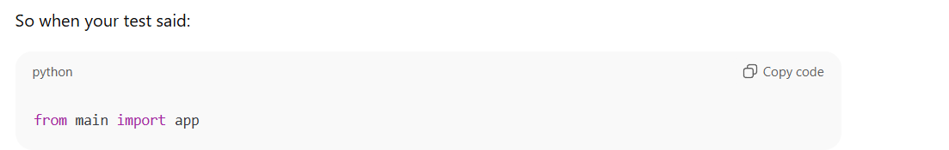
pytest couldn’t find main.py in the default search path.
💥 Why it happened:
You were running tests from the project root,
but your file main.py lived inside:

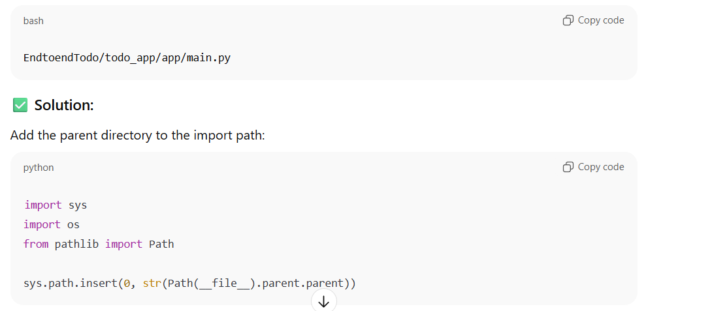
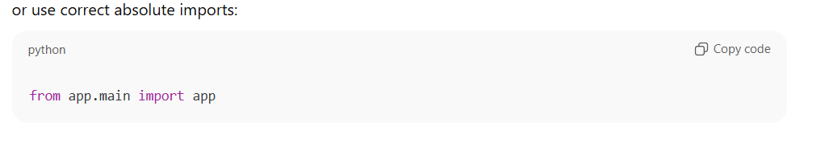

⚙️ ERROR 2 — ModuleNotFoundError: No module named 'fastapi'
🧠 Concept:
This was not a code issue — it’s an environment issue.
Your virtual environment didn’t have fastapi installed.
✅ Solution:
Install missing dependencies:
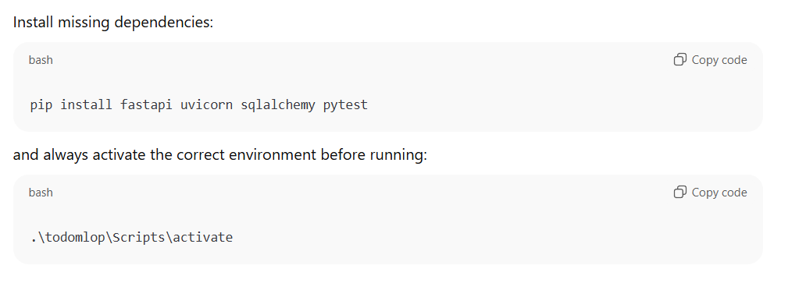
⚙️ ERROR 3 — ImportError: attempted relative import with no known parent package
🧠 Concept:
Python can only resolve relative imports (from . import xyz) when the file is part of a package
(i.e., a folder containing an __init__.py file).
Since you were running modules directly (not as part of a package), relative imports failed.
✅ Solution:
Use absolute imports instead:

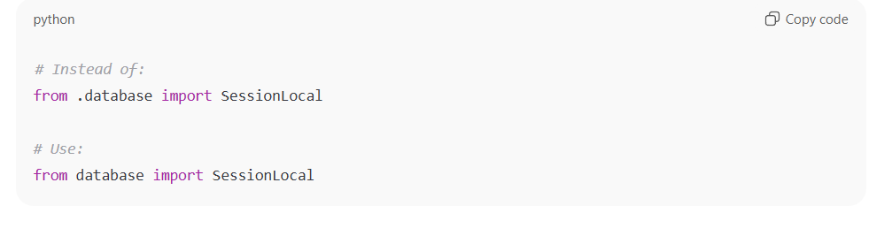

⚙️ ERROR 4 — sqlite3.OperationalError: no such table: tasks
🧠 Concept:
SQLite behaves differently depending on how you connect:
- "sqlite:///:memory:" → creates an in-memory DB per connection (disappears after each use)
- "sqlite://" → shared in-memory DB, but only within the same process
- "sqlite:///./todo.db" → file-based persistent DB
When FastAPI + Pytest used multiple database sessions, they each opened new connections → each had its own empty in-memory DB → no tables existed.

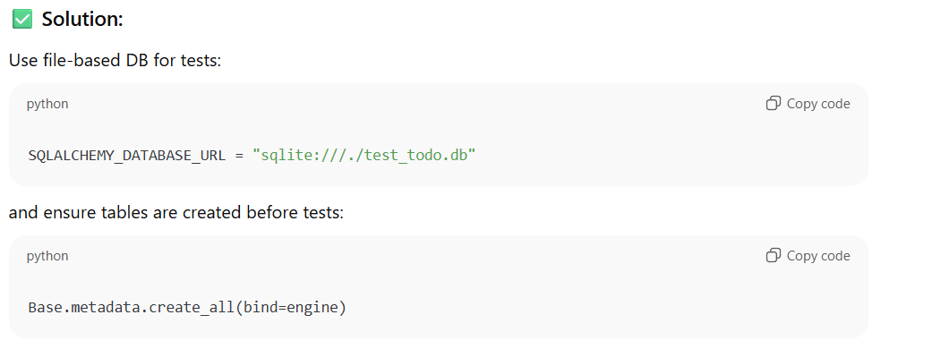

✅ Concept takeaway:
- In-memory DB is destroyed per connection.
- File-based DB ensures persistence and shared state.

⚙️ ERROR 5 — jinja2.exceptions.TemplateNotFound: 'index.html'
🧠 Concept:
FastAPI’s Jinja2 looks for templates relative to your current working directory (the folder you ran pytest from).
So when you ran tests from root (EndtoendTodo/),
FastAPI looked for:

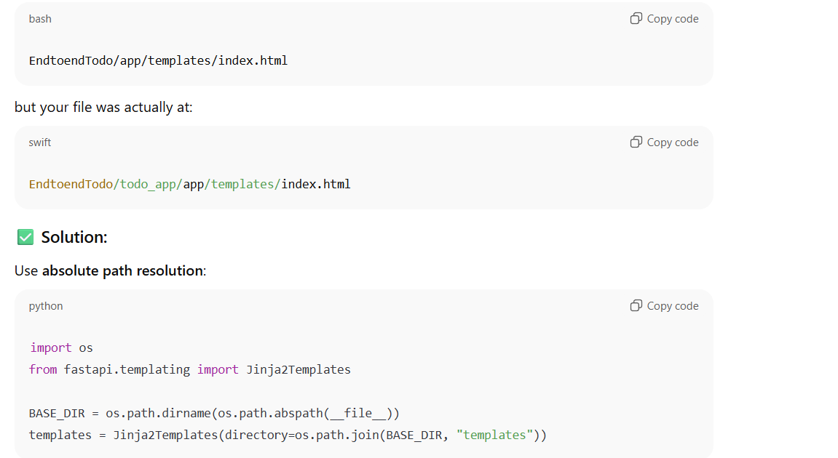

✅ Concept takeaway:
Always use absolute paths for templates, static, and data folders in production/test environments.

⚙️ ERROR 6 — AssertionError: assert 200 == 303
🧠 Concept:
FastAPI’s TestClient follows redirects automatically.
So even if your app returns RedirectResponse(status_code=303),
pytest sees the final redirected response (status 200).
✅ Solution 1 (Best):
Prevent auto-follow:

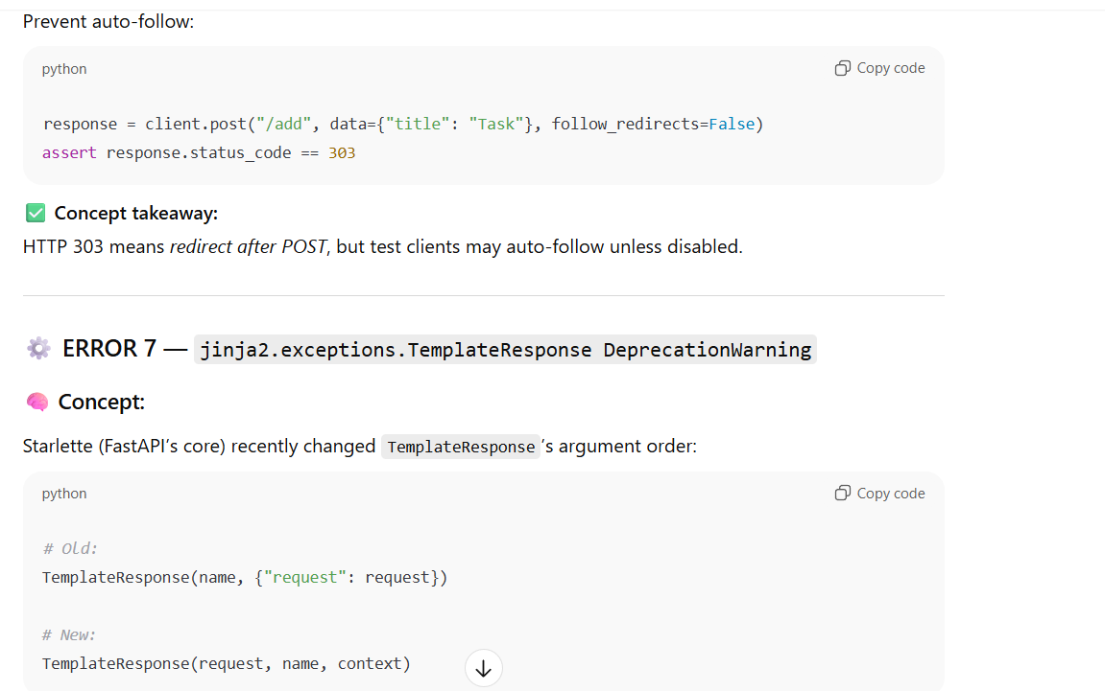

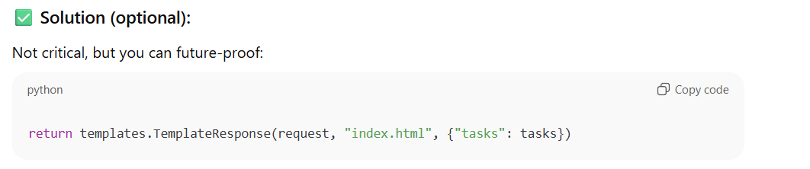
⚙️ ERROR 8 — Path confusion with Uvicorn (ModuleNotFoundError: No module named 'app')
🧠 Concept:
When you start a FastAPI app using Uvicorn,
the import path depends on your current working directory.
If you run from root:

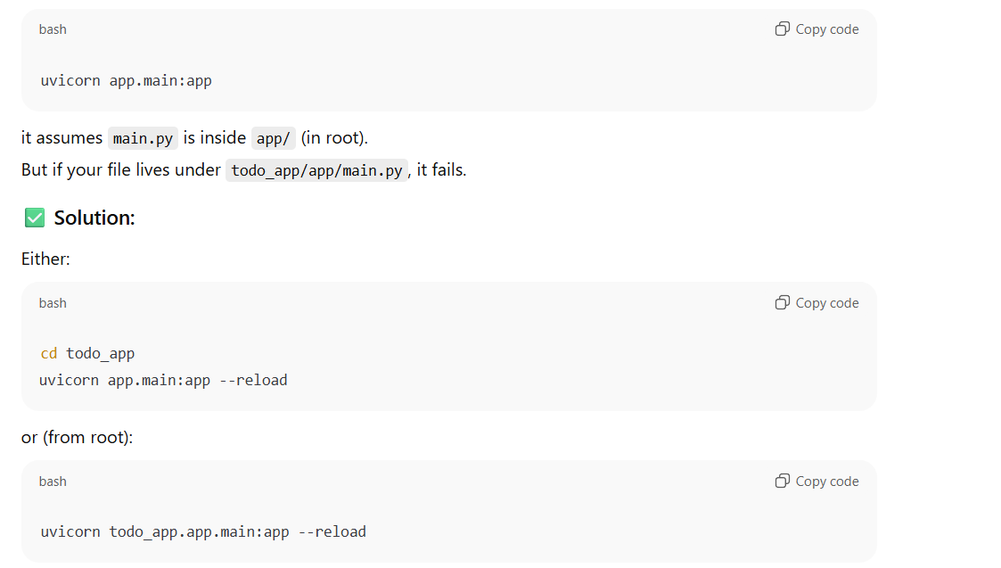
✅ Concept takeaway:
Uvicorn interprets module paths relative to where you run it, not where the file exists.

Problem | Root Cause | Fix | Concept
ModuleNotFoundError | Wrong import path | Absolute import / add sys.path | Python import system
Missing FastAPI | Virtual env issue | Install deps | Env isolation
Relative import fail | Missing package context | Use absolute import | Python package model
No table found | In-memory DB resets | Use file DB | SQLAlchemy connections
TemplateNotFound | Wrong path from pytest root | Use absolute path | Jinja2 search path
200 vs 303 mismatch | Redirect followed | Disable follow_redirects | HTTP redirect behavior
TemplateResponse warning | Deprecation | Update argument order | Starlette internal change
Uvicorn no module | Wrong cwd path | Use correct module path | Import path resolution

💡 Meta Learning — What You Actually Learned
- Import Systems in Python — how Python resolves modules and packages.
- FastAPI + SQLAlchemy integration flow — sessions, dependencies, and database lifecycles.
- SQLite connection behavior — difference between :memory:, sqlite://, and sqlite:///file.db.
- Jinja2 template resolution — absolute vs relative paths.
- HTTP flow testing — redirect responses, 303 behavior, and TestClient configs.
- CI/CD readiness — how to structure tests and project for GitHub Actions.

